**Assignment：Layout Steps**

1. **Set Global Styles**
   * Use * {box-sizing: border-box; } to ensure padding and borders are included in the element's width and height.
   * Set margin: 0; and padding: 0; for the body to remove default margins and padding.

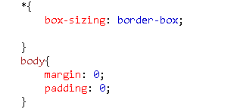

1. **Create Header**
   * Create a div element with the class header, set its width to 100%, and height to 100px.
   * Set the background color to grey, font to bold (bolder), font size to 40px, line height to 100px, and font family to sans-serif
   * Set text color to white and use padding-left: 20px; to add inner padding on the left.
   * Add the text "DaZhou" inside the header element.

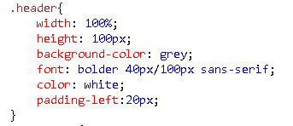

1. **Create Container**
   * Create a div element with the class container, set its width to 1200px, and use margin: 10px auto; to center it horizontally.
   * Add the clearfix class to clear floats (defined later in CSS).
   * Set content: , clear: both;, and display: table; to ensure content after floated elements displays correctly.

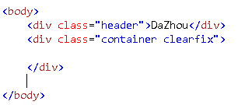

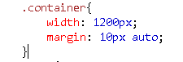

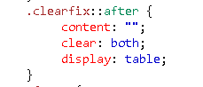

1. **Create Menu**
   * Inside the container, create a div element with the class menu, set its width to 300px, and margin-right: 10px;.
   * Use float: left; to float it to the left.
   * Create a ul element inside the menu and remove default list styles (list-style-type: none;), while setting margin: 0; and padding: 0;.
   * Add multiple li elements inside the ul, each representing a menu item.
   * Set li elements' background color to #33b5e5, padding to 8px, bottom margin to 16px, and text color to white.

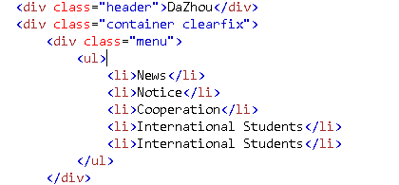

1. **Create Content Area**
   * Inside the container, create a div element with the class content, set its width to 890px (remaining width to ensure the total width doesn't exceed 1200px).
   * Use float: left; to float it to the right of the menu.
   * Add an h2 element inside the content to display the title "Sichuan University of Arts and Science".
   * Add a p element to contain information about the school.

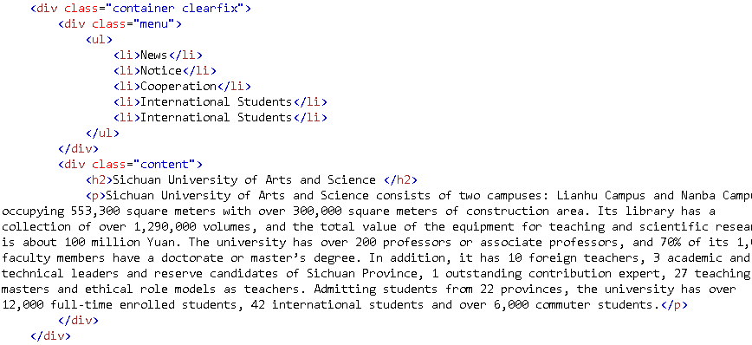

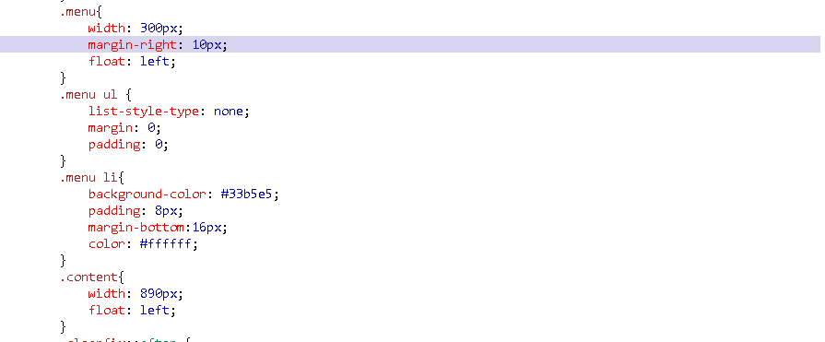

1. **Create Footer**
   * Create a div element with the class footer, set its width to 100%, and height to 100px.
   * Set the background color to grey, font to bold (bolder), font size to 40px, line height to 100px, and font family to sans-serif.
   * Set text color to white and use padding-left: 20px; to add inner padding on the left.
   * Add the text "Footer" inside the footer element.

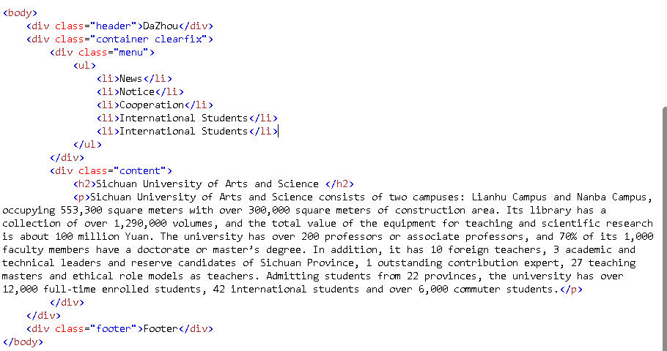

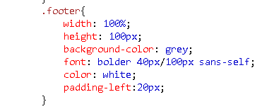

1. **Check and Adjust**
   * Ensure all elements' styles and layout meet the design requirements.
   * Check the page's responsiveness to ensure it displays correctly on different devices and screen sizes.

By following these steps, you can create the layout of this HTML page.

